Please look at these 9 locations plus bonus site carefully before you start. They do not need to be found in order. Some are outside so you will want to find those before the sun goes down. Also note the closure time of the bonus site.

Number 1
Clue – “Steak” your claim
31.80145 (31° 48' 5.22"N), -85.95599 (85° 57' 21.564"W)

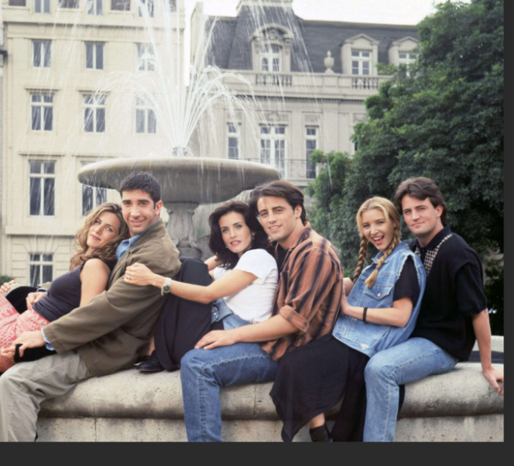
Number 2

Clue – Don’t get wet
31.79945 (31° 47' 58.02"N), -85.95715 (85° 57' 25.74"W)

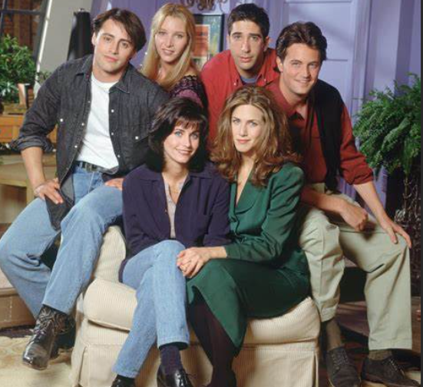
Number 3
Clue – Go left and look for a cozy chair
31.80162 (31° 48' 5.832"N), -85.95789 (85° 57' 28.404"W)

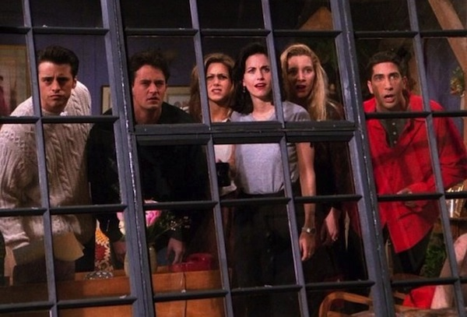
Number 4

Clue– where your journey at Troy began
31.79937 (31° 47' 57.732"N), -85.95795 (85° 57' 28.62"W)
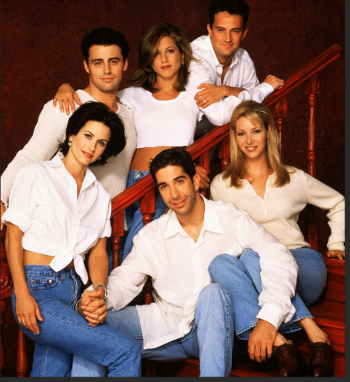
Number 5
Clue - enter from the back

31.80086 (31°48'03.3"N), -85.95703 (85°57'25.1"W)

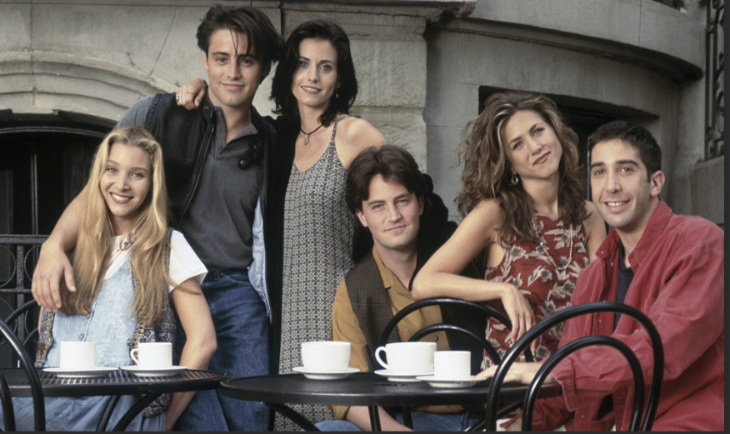

Number 6

Clue- Pull up a chair
31.80099 (31° 48' 3.564" N), -85.95578 (85° 57' 20.808"W)

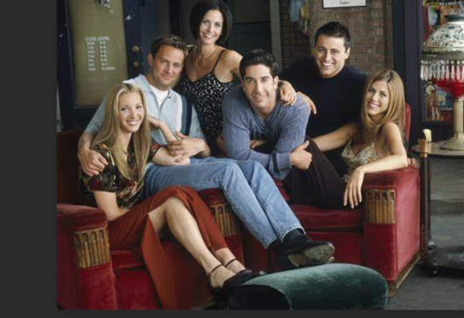

Number 7
Clue – Go up and get comfortable
31.80140 (31° 48' 5.04"N), -85.95572 (85° 57' 20.592"W)

Number 8
Clue – Geeks need to eat
31.79897 (31° 47' 56.292"N), -85.95656 (85° 57' 23.616"W)

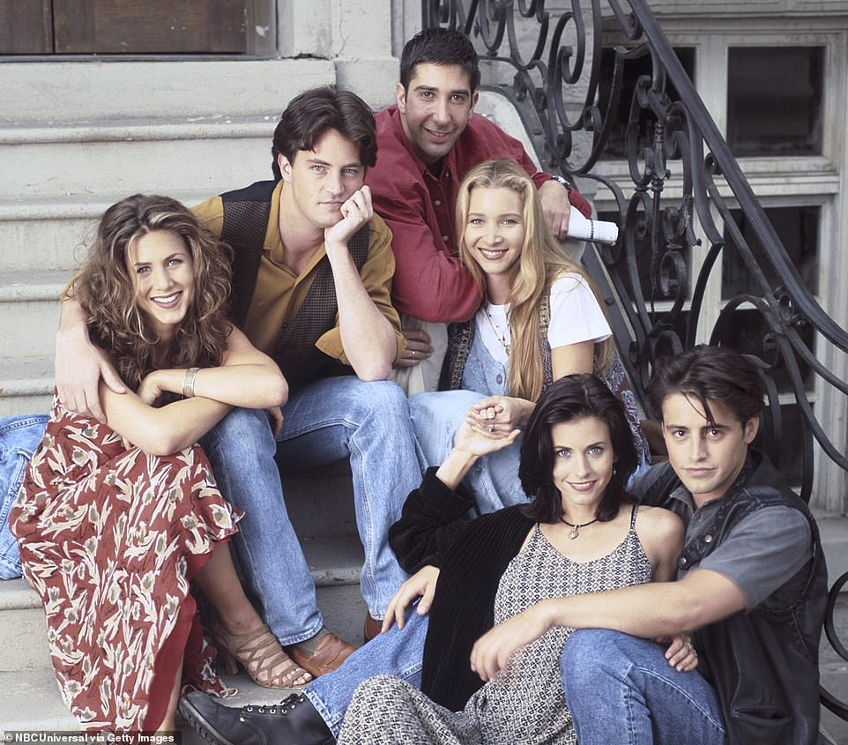
Number 9
Clue – There is a fountain to the left
31.79871 (31° 47' 55.356"N), -85.95884 (85° 57' 31.824"W)

BONUS LOCATION just for fun- upload one or more photos and enjoy a cup before 6:00 pm
31.80787 (31° 48' 28.332"N), -85.97252 (85° 58' 21.072"W)
