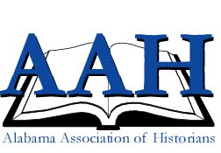
THE ALABAMA ASSOCIATION OF HISTORIANS
46th Annual Meeting
13-14 April 2018
DoubleTree by Hilton Birmingham
(808 20th St S, Birmingham, AL 35205)
Concurrently with the Alabama Historical Association

Call for PROPOSALs

The Program Committee welcomes proposals from members of the AAH, from affiliated societies, and from teachers, scholars, and public historians in all fields and disciplines of history. We welcome proposals for individual papers, posters, and traditional panels. If you have an oddball or experimental idea, pitch it and we will consider it.

Submission Deadline: 15 January 2018.

All proposals must include:

One-page abstract
CV or resume of presenter(s) with contact information

E-mail proposals for individual papers, posters, and panels to:

Marty Olliff
The Wiregrass Archives
Troy University Dothan Campus
molliff@troy.edu

The David Warren Bowen Award is presented for the best student paper submitted for the annual AAH Conference. To be considered, authors/presenters should indicate their student status. The award is sponsored by the Department of History and Social Sciences at the University of West Alabama. The winner will receive a certificate and an honorarium.

